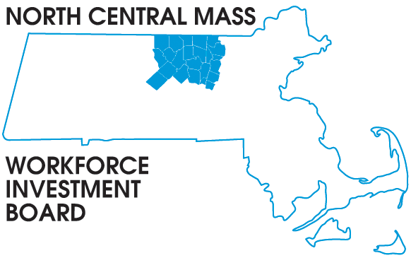

Posted 02/24/2014 at 3:08 pm by JAV

1355 Central Street Leominster, MA 01453 Phone: (978) 534 1023 Fax: (978) 534 1807

BOARD OF DIRECTORS MEETING

Tuesday, March 11, 2014

North Central Chamber of Commerce
860 South Street Fitchburg, MA
8:00 a.m. –9:30 a.m.

AGENDA

Welcome & Introductions

Approve Minutes of the November meeting (Vote required)

Executive Committee report Martha Chiarchiaro (Vote required)
Finance report Barbara Mahoney

Update Mount Wachusett Community College new $15.9 million TAACCT grant
Jacqueline Belrose

Presentation Fitchburg Working Cities Grant $400,000 Federal Reserve Bank Boston
Kathy McDermott

Workforce Competitive Trust Fund Grant & Meeting with Secretary Bialecki
Rosemary Chandler

Directors Report: In the NEWS

Other Business

